**USING RAPTOR – AMSTRONG NUMBER OR NOT**

**R.NIVEDITHA**

**192110054**

**FLOWCHART**

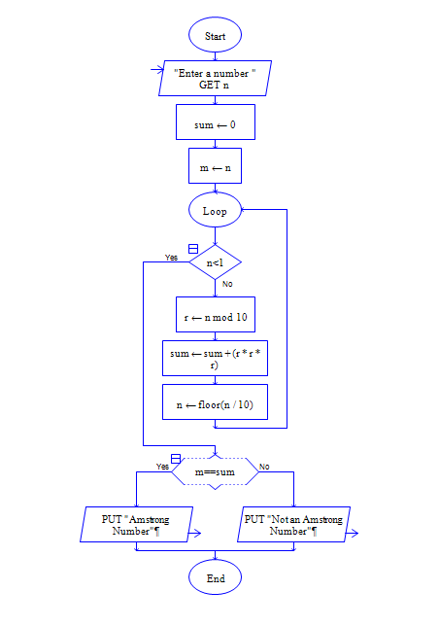

**INPUT**

371

**OUTPUT**

